W1800R-How to setup the router for Static IP internet connection mode?
Product line: Wireless Question category: Internet setup
Step1 Connect the devices
Step2 Configure your computer（Generally you can skip this step, unless you can’t do step3）
Step3 Setup the router
Step4 Check whether you can access internet

Connect the modem to the blue port of the router, then connect the router to your computer by a cable as the following picture.

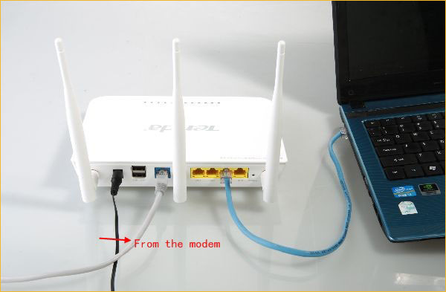

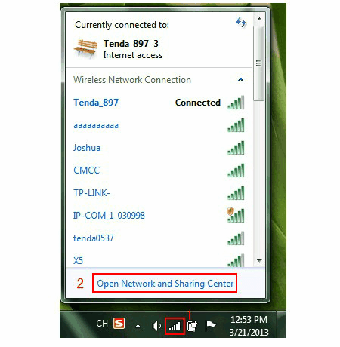

1.Open a browser or safari, then input 192.168.0.1 in the address bar, click Enter.
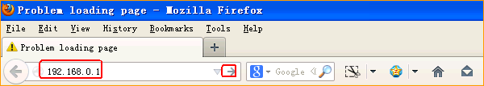

2. Input admin, admin, click Login.
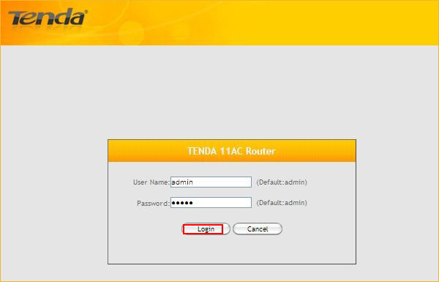
3.Click on Advanced.
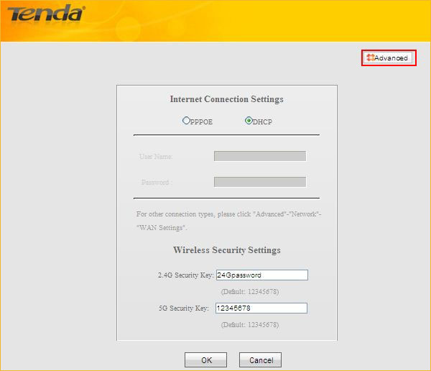
4.Click on Network, then click on WAN Settings, then choose Static IP as Internet Connection Type and input the information.
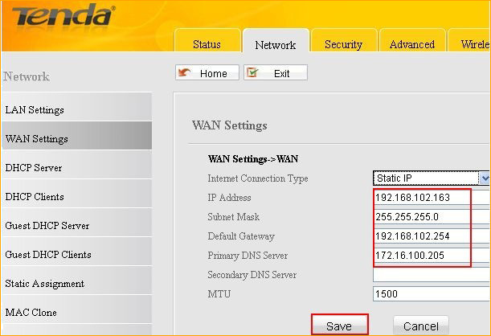

If the connection status shows Connected, it means that you can have internet. Please check.
